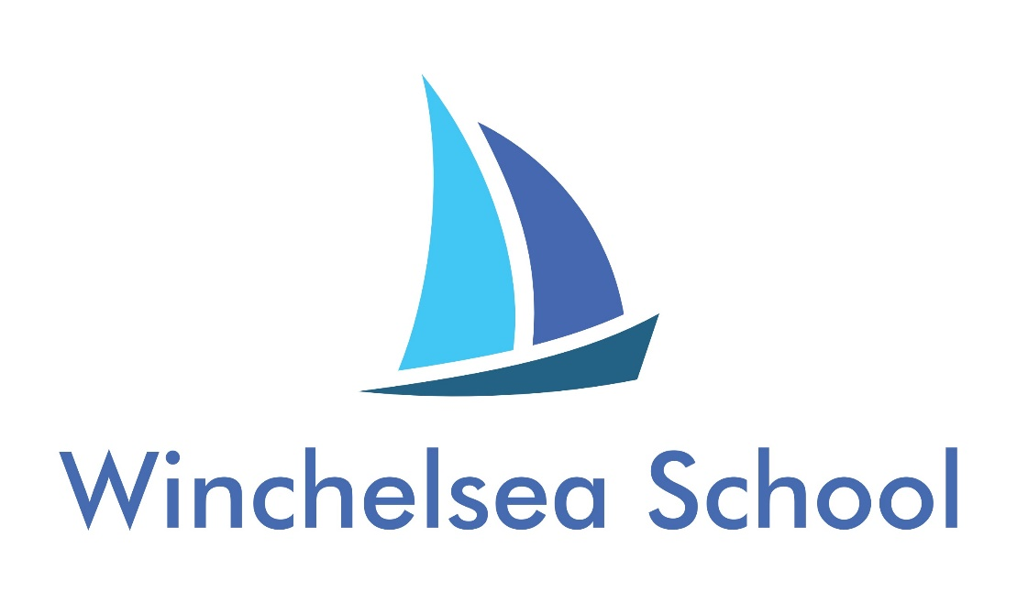
Guernsey Road
Poole BH12 4LL

Admissions Policy
Version | 1.2 |  | Review Date | 01.09.25
Review Cycle | Annually |  | Review Due | 01.09.26
Author / Owner |  | Headteacher

Introduction

Winchelsea School is a mixed, 4-19 Special School committed to meeting the educational needs of children who have an Education, Health & Care Plan (EHCP). These needs include Moderate Learning Difficulties, Global Development Delay, Attention Deficit Disorder, Attention Deficit Hyperactivity Disorder, Autism Spectrum Disorders and Mild Sensory and Physical Impairments.

Admissions may be made at any time during the school year, including Post 16, but the majority take place in September. All admissions are made in accordance with the current national legislation relating to pupils with special needs, and must conform to the school’s admission policy, as agreed with the Local Authority (LA). The school’s home LA is the Bournemouth, Christchurch and Poole Council.

The school is funded to provide a specific number of places by Bournemouth, Christchurch & Poole Council. There are no prescribed place numbers relating to the category of learning difficulty or Key Stage although an appropriate balance will always be sought. The school may, in certain circumstances agree to admit pupils beyond this number if it is confident that, in so doing, the needs of the pupils in the group are not compromised and appropriate agreement is reached concerning funding for additional place provision. The discretion to admit beyond the formula number remains with the Governors through the office of the Headteacher. Governors seek to allocate places on the basis of vacancies within groups rather than overall vacancies within the school.

All admissions are administered by Bournemouth, Christchurch & Poole Council. Occasionally admissions may be agreed for children from neighbouring authorities.

The following documentation will be required before consideration can be given for admission:

• Education, Health and Care Plan with supporting documentation.

• Draft Education, Health and Care Plan (in certain circumstances).

• Details of Stage 1, 2 and 3 of the Code of Practice as undertaken at mainstream if appropriate.

Prospective parents are welcome to visit the school while the statement is being drawn up although no formal offer of a place can be made.

In certain cases, pupils can be admitted for a fixed period on an assessment basis. In such cases, the pupil may not meet the requirements detailed above. Such admissions must be mutually agreed by the Governors and Bournemouth, Christchurch & Poole Council.

Following a request for placement from Bournemouth, Christchurch & Poole Council, the Headteacher may consult with staff within school, and other professionals beyond the school, as to the suitability of the placement.
Where a vacancy exists and it is felt that Winchelsea is an appropriate provision to meet a child's needs, parents/guardians and the prospective pupil are invited into school for an admissions meeting.

Places are offered subject to availability and to the suitability of the placement to meet a child's perceived educational needs. In all cases, appropriate transition arrangements will be discussed in order to support a successful start to the placement.

An essential requirement of a pupil joining the school is that parents feel they can fully support the proposals set out on the school website and wish to develop a sense of mutual co-operation on behalf of their child. The school website incorporates the aims, values and responsibilities accepted by both the school and parent in connection with the education of the pupil. Parents will be requested to sign the School's Home/School Partnership Agreement although admission is not dependent on signing the document.

When parents formally request a place for their child, and this is agreed, a letter of confirmation is sent by the appropriate LA. Bournemouth, Christchurch & Poole Council will then make transport arrangements if applicable. If the pupil is transitioning from another school, then that school will be contacted to agree appropriate transition arrangements. These arrangements will be based upon the needs of the pupil.

Issues relating to offers of a place by Bournemouth, Christchurch & Poole Council which conflict with parental preference or requirements will be dealt with by the LA through the accepted procedure, or if necessary, by Tribunal.

Formal Reviews will be held annually to determine the ongoing suitability of the placement.

Post 16 Provision

The school provides Post 16 education to children with Moderate Learning Difficulties. The majority of our pupils remain with us until they are 18. However, a small number will access alternative mainstream provision or alternative specialist provision at Post 16. If either of these are potential outcomes beyond Year 11, this will be discussed as appropriate at Annual reviews from Year 9 onwards.

Satellite Provision / The Upper Link (Broadstone Middle School)

The school provides a number of satellite classes across the 5-16 age group. Admissions to these provisions are the same as those for the main site. All requests for places will be considered across the full range of provisions at Winchelsea School. Direct requests for a satellite place will not be considered as all places will have Winchelsea School named on the EHCP. In addition, all requests for place at The Upper Link site at Broadstone Middle School should be made in the same way. These requests will be responded to in collaboration with Broadstone Middle School.

Current Part-Time to Full-Time Attendance for 4 Year Olds

Bournemouth, Christchurch & Poole Council’s policy is that children attend fulltime from the start of the term in which they turn 5. However, in consultation with parents and other appropriate professionals, we may on occasion be willing to consider offering fulltime attendance to 4 year old children.

